YEAR 8 SCIENCE – TERM 4 PHYSICS REVISION

The following equations may be useful:

$$GPE=m×g×h$$
$$KE=1/2mv^{2}$$

1 Define the term ENERGY

2 a) Classify the following types of energy as either Kinetic or Potential:

Chemical Elastic
Mechanical Electrical
Sound Gravitational
Radiant Thermal

b) For each of the energy types listed above, give at least two examples of each

3 Identify which factors affect the total amount of:
- Kinetic energy
- Potential energy

4 a) Explain the difference between an energy transfer and an energy transformation.

b) Complete the following sentences using the words transferred and/or transformed.

On a table, when you slide a box across it, the chemical energy in your body is ____________ to kinetic energy to move your hand. When you push the box, the kinetic energy in your hand is ___________ to move the box.

5 Define what is meant by waste energy.

6 Identify the unit needed for each of the following in the KE and GPE formulas:

- mass
- velocity
- time
- height
- gravitational acceleration
- Kinetic energy
- Potential energy

7 Draw an energy chain to show what energy transers/transformations occur during the following processes
- A violin makes a sound when you draw the bow across the string. (starting with a person moving the bow).
- A car driving along a road

8 a) State The Law of Conservation of Energy
b) Answer True or False for each of the following statements about the Law of
Conservation of energy:

_______ The totals of all energy transfers and transformations when work is done
must equal the initial energy put into the system.
_______ Energy not used to do work can be given off as waste energy.
________ Energy released during a nuclear explosion is greater than the
potential energy stored in the atoms.
________The energy stored in a stretched spring is equal to the energy
required to stretch that spring plus the energy lost as heat to friction.

9 Consider the points A, B, C and D on the missile launch diagram below:

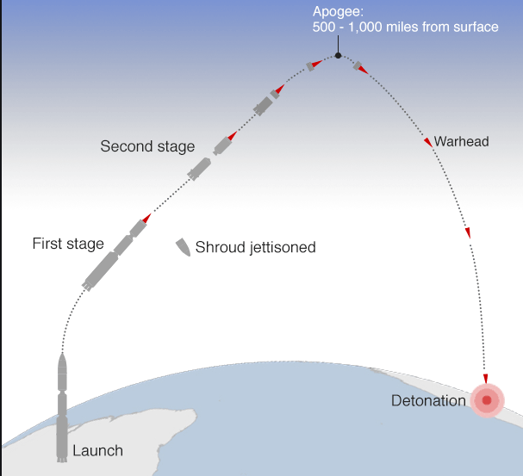
B
C
A
D

At which point (A, B, C or D) does the missile have the least gravitational potential energy? Explain.

10 Complete the table below to identify the energy transformation caused by each energy converter:

Main energy form used | Energy converter | Main energy form produced
 | light bulb
 | speaker
 | car
 | bicycle
 | plant

11 Compare the waste energy of television A with television B shown below and explain which television would be considered the best to use.
Sound: 1800J
Light: 1800J
Heat: 400J
Television B
4000J
Light: 1500J
Heat: 1000J
Sound: 1500J
Television A
4000J

12 Classify the following as a type of potential energy or kinetic energy (use the letters KE or PE)

a. A bicyclist pedaling up a hill _____ f. An archer with his bow drawn _____

b. A volleyball player spiking a ball _____ g. A baseball thrown to second base _____

c. The chemical bonds in sugar _____ h. The wind blowing through your hair _____

d. Walking down the street _____ i. Sitting in the top of a tree _____

e. A bowling ball rolling down the alley _____ j. A bowling ball sitting on the rack _____

13 The diagram below shows a basketball after it has been thrown by a player:

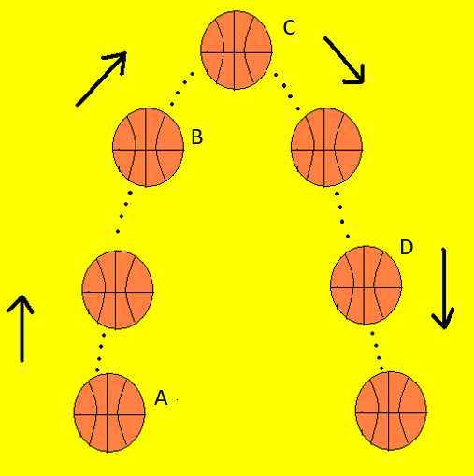

Choose the graph below that best represents the potential and kinetic energy of the ball at each labelled position (A,B,C and D). Explain your choices.

Graph 1 | Graph 2 | Graph 3 | Graph 4 | Graph 5
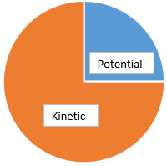 | 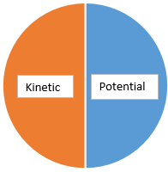 | 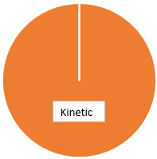 | 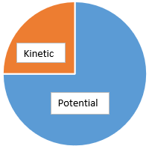 | 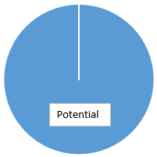

14 Calculate the kinetic energy of a 2.56 kg ball travelling at 16 m/s

15 Fearless Felix is on his balloon 30,000m in the air above the ground. With all his equipment his mass is 145kg. Calculate his gravitational potential energy before he jumps.

16 A rollercoaster is at the top of its climb and weighs 900kg. It has 10 000J of GPE. Calculate the height of the roller coaster.

17 Calculate the velocity of a bike rider who takes 8 seconds to ride down a path 20m long.

18 For each of the following, identify which type of energy is being described, then calculate it.

- You serve a volleyball with a mass of 2.1 kg. The ball leaves your hand with a speed of 30 m/s.
- A baby carriage is sitting at the top of a hill that is 21 m high. The carriage with the baby weighs 12kg.
- A car is traveling with a velocity of 40 m/s and has a mass of 1120 kg.
- A block is sitting on a platform 20 m high. It weighs 79 kg.
- There is a bell at the top of a tower that is 45 m high. The bell weighs 90 kg.
- A roller coaster is stopped at the top of a 72 m hill and weighs 966 kg.
19 Calculate the kinetic energy of a 3-kilogram ball that is rolling at 2 metres per second.
20 Two objects were lifted by a machine. One object had a mass of 2 kilograms, and was lifted at a speed of 2 m/sec. The other had a mass of 4 kilograms and was lifted at a rate of 3 m/sec.
a. Which object had more kinetic energy while it was being lifted?
b. Which object had more potential energy when it was lifted to a distance of 10 metres?
Show your calculation.

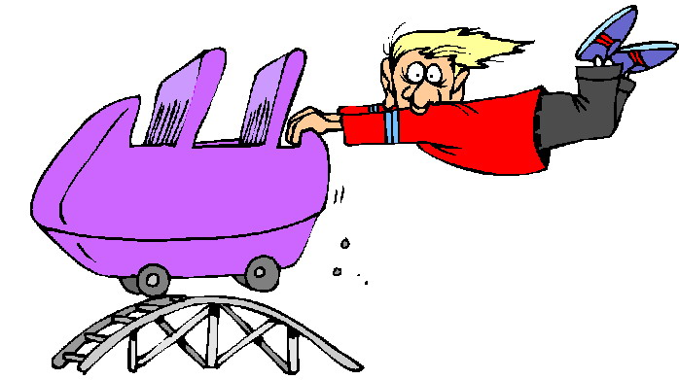
This Photo by Unknown Author is licensed under CC BY-NC-ND

